2021
United disabilities services foundation | 2270 Erin Court, Lancaster, PA 17601
IT Support Guide
instructional guide and responsibilities

Table of Contents
Form Tracker 5
Creating Users and Staff 5
Adding Participants 5
Assigning Participants to Staff 5
Removing Forms 5
Troubleshooting Form Tracker 6
Common Issues 6
Participants still listed under SC 6
UDS Audits – The QMET Process 6
Contact Information 7
Multiple Factor Authentication (MFA) Guide 8
Important Information: 8
Connected Sign 20
Uploading Images 20
Uploading Websites 20
Uploading Videos 20
Creating a Template 20
Backgrounds 21
Text 21
Date & Time 21
Shapes 21
Data Grid 22
Images 22
Creating a Data Feed 23
Server Feed 23
RSS Feed 23
Creating a Playlist 24
Adding Content to a Playlist 24
Adding Data to a Data Grid (Power User) 24
Adding Data to a Data Grid (End User) 25
Scheduling a Playlist 25
Playlist Properties 25
Publishing a Playlist 26
Basic Information and Additional Resources 26
Contact Information 26
Media Conversion 27
Image Conversion 27
Video Conversion 27
SharePoint 28
Page Creation 28
Subsite Creation 28
Modifying A Site 28
Changing a library 28
Modifying views 29
Adding Navigation Links to a Site 29
Adding Images to a Site 29
SharePoint Designer 30
Changing Page Theme 30
Color Palette Identifier 31
Adding Photos to Contacts Directory 31
Uploading Files 32
Adding Libraries 32
Permissions 33
Learning Map 33
Page Permissions 33
New Computer and Printer Setup 34
Software Configurations 34
Hardware Provided 34
New Computer 34
Initial Configuration 35
Printing on the SC-Area Copier Only 35
Finalizing Workstation Setup 35
Automate Installation 36
Automate Name Change 36
SAMS Shortcut Creation – HCBS ONLY 36
For Domain Workstation Setups ONLY 38
Account Setup 39
Form Tracker Account 39
Configuration of User Account 40
Department Signature Templates 42
HCBS 42
IT, HR, Administration, Facilities 43
Service Dogs 43
CWS, HME 44
Home Modifications 44
Key Fobs 45
New Hire Check List 45
New Printer 46
Meter Readings 47
Inventory Tracking 48
UDS Inventory Audits 48
Software Tracking 48
Verizon 48
How to Forward a Phone to an Extension & Setup Jabber 49
Barracuda 52
Recovering a file using Barracuda Backup 52
Email Filter 52
Open DNS 53
Cell Phone Configuration 53
On-Call Setup for SCs 54
Faxing 54
From Computer 54
From Copier 54
Domain Error Troubleshooting 54
Copier Color Issues 55
Database Troubleshooting 55
UDS Caseloads 55
UDS HALO 55
Yarnell Door Access 56
Accessing the Web Portal 56
Adding Users 56
Erin Court 56
Corporate Blvd 56
Documenting Users 56
Common Issues 57
Problem: Copier can't communicate to SMTP Server 57
Resolution 57
Contact Information 58
UDS Copiers 58
Server Information 58
Software Web URLs 59

Form Tracker

Creating Users and Staff
- Navigate to https://formtracker.udservices.org/users/login
- If you are creating a new HCBS staff member, proceed to step 3. If you are creating a new Admin, proceed to Step 7.
- Click the Staff Tab
- Choose “Create New Staff” on the left
- Fill in all information, username is the same as network account. If you do not know their supervisor or manager, you may leave it blank.
- Click Save when finished.
- Click the Admin Tab
- Choose “Create New User” on the left
- Replicate information from network and email account. Leave password blank. Choose Active Checkbox and Click Create.
- Choose new role and assign the correct value.
  - SC = Staff
  - SC II = Supervisor
  - Program Specialist = Manager
  - IT Staff or Admin rights = Admin

Adding Participants
- Click the Participants Tab
- Choose “Create New Participant” on the left hand side
- Fill in any information you know
- Click Save

Assigning Participants to Staff
- Click the Participants Tab
- Browse or Search for Participant
- Click the Participants Last name (highlighted in blue)
- Click the Staff link on the left
- Choose “Assign New Staff”
- Click the drop-down and find the correct staff member. (List is ordered alphabetically by last name)
- Add Start Date and choose as Primary
- Click Save

Removing Forms
- Click on the Participants Tab
- Browse or Search for the Participant
- Click the Participants Last name (highlighted in blue)
- Click the “trash can” next to the form remove it
(Note: Forms are archived, not deleted)

Troubleshooting Form Tracker
All information removed from Form Tracker gets archived, not deleted and therefore can be recovered.
- If information needs to be recovered or a request to made a change needs to be made, navigate to the help desk for Annkissam: https://annkissam.sifterapp.com/login
- After logging in, Select New Issue
- Provide the information that is needed, choose the correct priority, select Allison as the Assignee and choose the appropriate category.
- Click submit when finished.

Common Issues

Participants still listed under SC
- First obtain which participants are still showing up under the SC that need to be moved
- Open Form Tracker: https://formtracker.udservices.org/users/login
- Click the Participants Tab
- Search for the participant
- Click the Staff link on the left hand side
- If the wrong person is still listed, their name will also state they are the primary Service coordinator Click the pen and pad next to the person’s name that needs this participant removed
- Change the Primary value from Yes to No
- Click Update to make the change

UDS Audits – The QMET Process
Each year, QMET reviews billing and participant documentation performed by UDS, specifically the HCBS Department. Data is stored in various applications and databases as well as our document management system, Form Tracker.
Auditors need access to participant information within this application, therefore 5 accounts have been preloaded. Qmet1, qmet2, qmet3, qmet4, qmet5. Each of these accounts uses the same password: Password
To Prepare for an Audit, participants need to be assigned to the various qmet accounts. This is done exactly like adding a participant to an existing staff member.
- Open a web browser and in the address bar, type https://formtracker.udservices.org
- Login with your username and password
- Click the participants tab
- Type the participants name and search
- Once the participant is found, click their name
- Once the demographic page opens, click staff on the left
- The staff window will open, click add staff
- Add the qmet account, set as primary and choose the day your adding it
- Click update when finished.
- Repeat this process if a participant is being assigned to more than one qmet account
To grant auditors access through our applications, follow these steps:
- Log their computers into the UDSFErinCT wifi
- Open a web browser and type: https://formtracker.udservices.org
- Assign a login to them to use
- At this point, a Program Specialist will direct them on what to do
Upon completion of an Audit, Access will need to be taken off those qmet accounts. To do this,
- Open a web browser and in the address bar, type https://formtracker.udservices.org
- Login with your username and password
- Click the Staff tab
- Look for each qmet account and click on the name
- Click each participant
- Once the demographic page opens, click staff on the left
- The staff window will open. Click the “pen and paper next to the qmet account
- Uncheck primary and add the end date
- Click update when finished
- Repeat steps 7-10 for other qmet accounts

Contact Information
Allison Dyer
Annkissam
allison.dyer@annkissam.com
Office: 617-401-2480, ext. 705
Toll Free: 888-434-6931
Fax: 617-507-5922

Multiple Factor Authentication (MFA) Guide

This guide provides the step-by-step instruction for how to use Multiple Factor Authentication (MFA), including how the login process for accessing the AmeriHealth Caritas eLTSS website will function with MFA.

Important Information:

- All users must authenticate into the eLTSS system.
- External users will use Multi Factor Authentication (MFA) each time when logging into the AmeriHealth Caritas eLTSS system.
- MFA will not be needed when working offline (without internet connection) on an assessment that has been downloaded for offline use.

How to obtain the “Setup TOTP Authentication” information:

New Users: When your login account has been created, you will receive an email to confirm your account. Your account will need to be confirmed within seven days, otherwise a new confirmation will need to be requested. After clicking the link to confirm the account, the “Setup TOTP Authentication” page will display – this will be needed to setup your authenticator program. Sample email below:
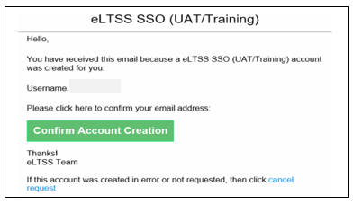
-------------------------------------------------------------------------------------------------------------

Using your chosen AUTHENTICATOR program:
- Once you have your “Setup TOTP Authentication” information opened on the website, double click the “WinAuth” file to open.
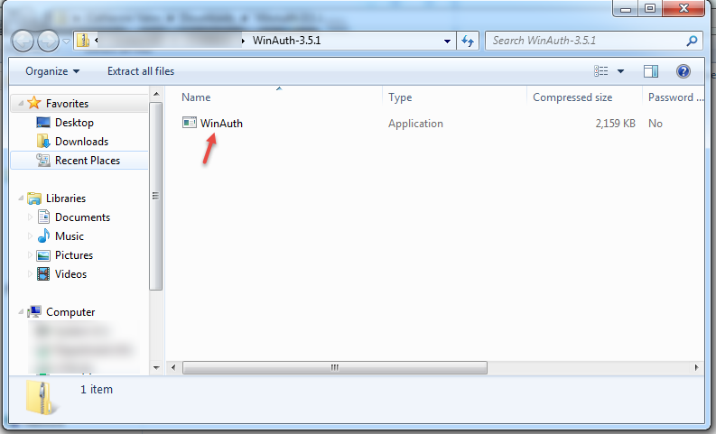

- You will be prompted to verify you would like to run this file. Click “Run” to continue.
` 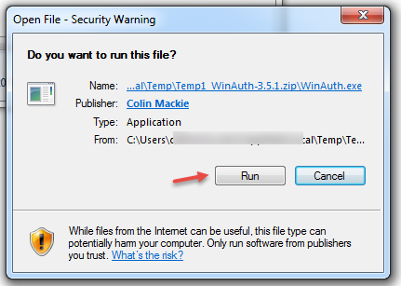

- The WinAuth window will open. Click “Add” to begin the setup. You must keep the “Setup TOTP Authentication” information open & easily viewable for the remaining steps.
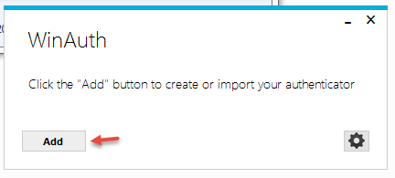
- Choose the first option in the menu – “Authenticator”
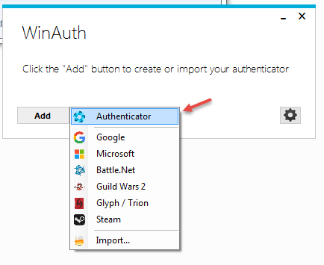

- The “Add Authenticator” window is where you will setup the program to work with the AmeriHealth Caritas eLTSS site.

- In the Name field, change the name to ‘AmeriHealth Caritas eLTSS’ or another name of your choosing.
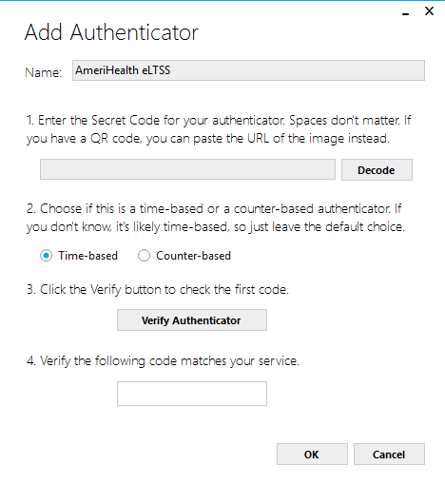

- Return to the “Setup TOTP Authentication” information – please refer to the screenshot below for guidance with the remaining steps.
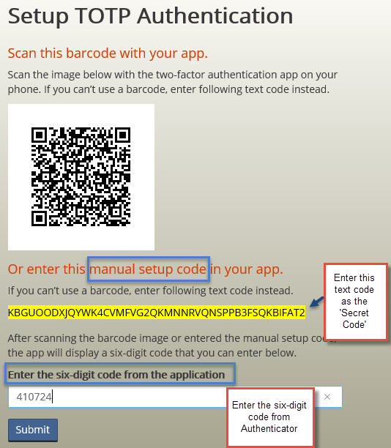
- Refer to the email received regarding setup of TOTP Authentication. The email that you receive will contain information that looks just like the screenshot above. Copy the text code in the yellow box (referred to as the “manual setup code”) from your email.

- Once the code is copied, return to the “Add Authenticator window” and paste the text code in the field under “Enter the Secret Code for your authenticator.”
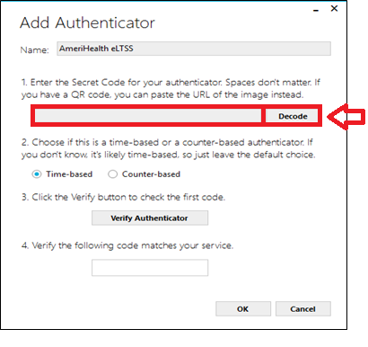
- “Time-based” should be pre-selected for step two, please leave as is.
- Click the “Verify Authenticator” button shown under step three.
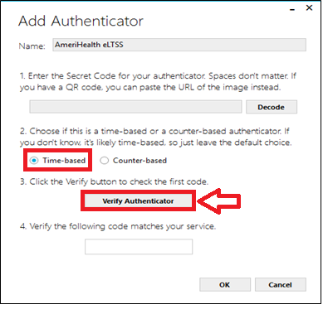

- A six digit code will populate in the field at the bottom of the window. Enter that same six digit code into the field at the bottom (under “Enter the six-digit code from the application”).

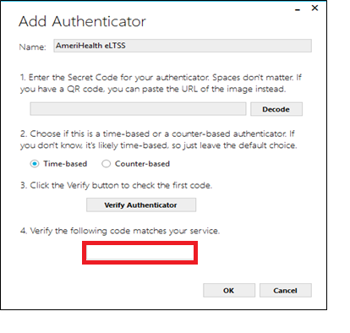
- Click Submit to continue and be directed to the Protection Screen. The protection screen allows you to enter in a password to protect the authenticator. If you do not want to enter in a password just select CANCEL. We recommend NOT entering in the password at this time.
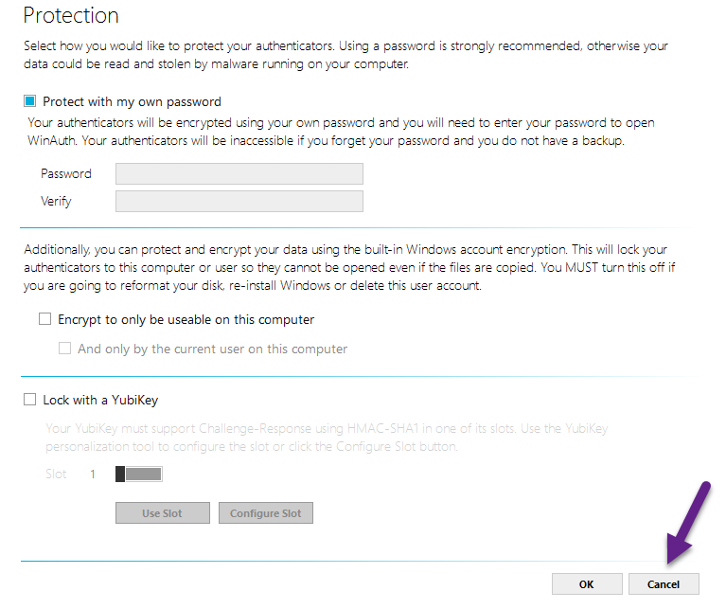
Once CANCEL is selected you are ready to use the WINAUTH Authenticator to generate a code. Just select the Circle with the Arrow.

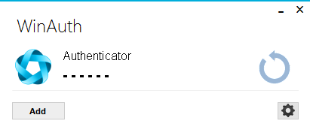

- Click Submit to add the username & password entry for the site.
- Return to the “Add Authenticator” window and click “OK” to finish.
The Authenticator has now been properly setup. Following this setup & for all future logins, you will be required to “Enter the validation code” after successfully entering your username and password.
Your Authenticator program will generate a six digit code each time to use as the validation code.
The six-digit code will be different each time one is generated. Be sure to keep your authentication app or program easily accessible whenever you need to access the site.
External - NEW USERS – Initial Login Steps (Once MFA is Set-Up)
- Once a new user account has been created, and authorized for MFA in the AmeriHealth Caritas site, an email will be sent to the new user account. The user has followed one of the choices above and is ready to go.
- User receives an initial email.
- Staff will have 7 days to select the link in the email to begin the setup in the system.
  - Select the link Confirm Account Creation in the email to begin.
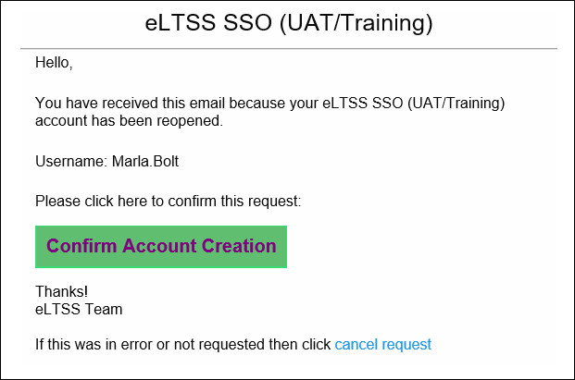
- User will see the Setup for TOTP Authentication on the next screen
- Enter the text code into the desktop application to receive the 6 digit code. Enter the 6 Digit code
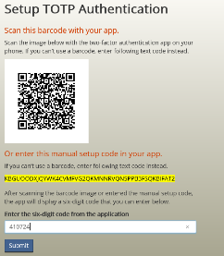

- Create a password – select submit
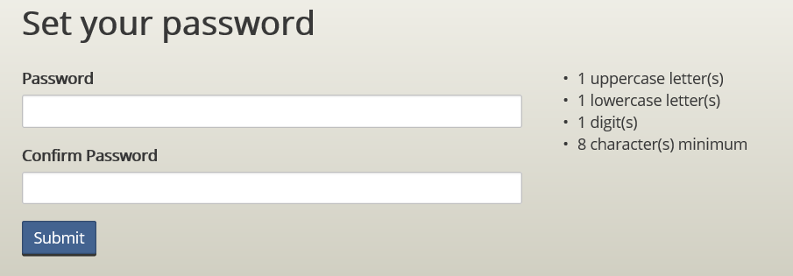

- Users will not be directed to login page automatically, they need to manual enter the URL of production site into browse.
PA: https://amerihealth-pennsylvania.eltss.org
  - Enter in User Name and Password
  - Select Log In
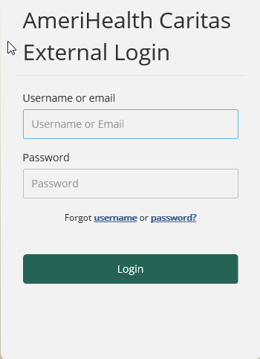

- MFA –enter in the 6 digit code. This code is obtained from your desktop authenticator.
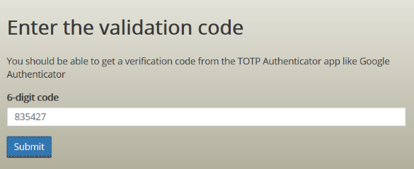
- Once entered, the user should land on the home page.
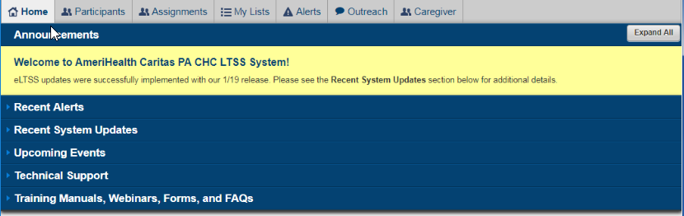

Connected Sign

Uploading Images
- Login to the web interface of the application through the website: http://cscloud.connectedsign.com/digitalsignage/WebUI/Login#no-back-button
- After logging, take note of the various columns. To Upload content, look at the Content column
- To add an image, click the images text under Media & Templates
- Right-Click the blank space and choose Add > Media
- Click Select Files
- Browse to the files you wish to upload. You may upload as many as want at one time.
- When finished selecting the images you want, Click Upload Files
- After the upload is finished, click OK.

Uploading Websites
- To Upload a website, browse to the site on separate browser or tab
- Copy the full URL
- Click Web Page under Media & Templates
- Right-Click in the blank space and select Add > URL
- Paste the copied URL in the URL Field
- Make sure it is enabled
- Under the duration, select how long you want the website to stay available, Hour, Min., Sec.
- Click Save when Finished

Uploading Videos
- To upload a video, click the Videos text under Media & Templates
- Right-Click in the blank space and select Add > Media
- Click Select Files
- Browse to the files you wish to upload. You may upload as many as want at one time.
- When finished selecting the images you want, Click Upload Files
- After the upload is finished, click OK.

Creating a Template
- Under Media & Templates, right-click and choose Add > Template
- Starting with a blank slate, images, media, data feeds, shapes, date/time, text, and datagrid can be added. A background can also be used.
- Add a time limit at the top of the window for how long the template will appear. Hr:Min:Sec.

Backgrounds
    - To add A background, Click the BACKGROUND button on the left. You can choose a color or an image. If you wish to add an image to select from, click Add underneath Type.
    - Click Select File to Browse or Search for a file.
    - After you find the file, click Ok in the open window
    - You will return to the Upload Media Window in ConnectedSign
    - Click Upload
    - Once the file has been uploaded, Click OK.
    - To load the image as your background into the Template, Double-click the image and it will appear in your template

Text
- To Add Text to your Template, Right above ZONE, there is an image that looks like a Box with a “T” in it. This is the Text Box. Click this to add text to your template.
- A text box will appear on your template. Drag the box to where ever you need it. You can resize the box by placing your cursor on the sides of the text box.
- Click the TEXT button on the left
- In the Body below the arrows, Type what you wish to see in the Text box
- You can change the font, font size, font look and color as well as centering the text and spacing it within the box. The arrows are used to center the text within the box vertically.

Date & Time
- To Add the Date and Time, Click the Date & Time button on the left.
- Click the drop arrow for Time to change the format
- Click the drop arrow in Date to change the format
- To Add the date to your template, Click the Calendar button at the top, which looks like a rectangle with numbers in it. Click the Clock at the top to add the time.
- This creates a text box for these elements. To change font, font options, and color, Click the date or time field, then click the text button and select your options

Shapes
- To Add a shape, Click the Shape button on the left
- Choose the form you wish to add
- Select the border color
- Choose whether you want the shape to be plain or gradient
- The first field next to the border color is for border thickness
- The second field next to border thickness is for roundness of corners. This field will only provide changes on the rectangular border.
- When you add a gradient to the shape, the gradient will only apply to the fill of the shape, not the border
- You can choose to send back or bring forward shapes. This can be useful when placing behind text.

Data Grid
- To add a datagrid, Click the spreadsheet icon on the left
- This will place a box in your template. You may resize it as you please as this is where data from a spreadsheet will show.
- To add data, click the Data Feed Manager button (highlighted in Grey) on the right
      - Click the drop-down arrow at the top where it says CNN and choose Visitors
      - The titles of the columns can be changed by selecting a cell below them, choose Display options on the right and changing the name
- To Add data, simply click a cell and add information
      - For the Logo, the cells are predefined to accept images. When you double-click on a cell, the Upload Media window will appear. Click Select file, locate the file, Click upload and then Click OK when finished
      - The image will appear as a URL
- If you want specific information and not all columns, Click Display Options on the right
      - Under Columns, click the drop-down arrow and next to the text click to choose select the checkbox
- When you are finished filling in all information and making preference changes, Click OK in the Top-Right Corner
- Under Data Feed Manager, Click the drop down to select the appropriate spreadsheet
      - Drag and drop a column name to the data grid
      - You can re-order the columns by dragging and moving them
      - To remove them, right-click and choose remove
      - To resize the column size, Double-click the datagrid. This will unlock the spreadsheet. When finished, click the grey icon in the upper right-hand corner of the grid.
      - When finished, click Apply on the right, under Data Feed Manager

Images
- To add an image to a template, Click Top Layers on the right
- Right Click with the space and choose Add > New
- The Upload Media Window will appear
- Find the images you need and Click Ok
- You will return to the Upload media window
- Click Upload
- When the upload finishes, click OK
- Drag and drop the image into the template. You can move the file to any location you need as well as resize it by dragging your cursors from the corners and sides of the image field
  - At the top of the Template designer window, there is a field next to the right of the template designer text. This is the Template title field. Type a name for the template.
    - Then Click save

Creating a Data Feed

Server Feed
- A server feed is a traditional spreadsheet where you can add different columns of information. This comes as a blank spreadsheet. To rename columns, Click the display options on the left.
- Double-Click the Column Name
- The Columns menu on the left will open. Specify if the column will be text or an image
- Change the column name next to name
- Click Save when finished.
- Repeat the process for the other columns
- When finished, Click OK.

RSS Feed
- A data feed can be done within a template or as a Ticker. A Ticker is an element that appears on every template or other media regardless if it is added or not.
- To Add a Ticker, expand, if not already, the option under Media & Templates
- Click “Not Published”
- Right-click in the blank space and choose Add > Ticker
- If you use a website, only RSS feeds can be used so please search for a site with an RSS feed and copy the URL
- The space provided is transparent in the ticker and is the maximum space that can be used. Start by putting a background that will identify the size of the ticker you will use. Make sure the background and text are opposite colors for legibility. Refer to page 5 – Background, for adding a background.
- Once you have your background size and shape set, Click Data Feed Manager on the left
- Under News Feed, provide a label for the Feed under Name and Paste the RSS Feed URL in the URL Body
- Click Save
- Click Display Options
- Make sure Image within cell is checked and ignore HTML Code is checked
- Under the Columns drop-down menu, select the fields you would like to have available to add to the ticker
- Click OK in the upper right-hand corner when finished.
- If you choose to add an image, say for a URL Website, click Top Layers
- Add the Top Layer as stated in the Images section on page 7
- Drag and drop the image in the Data feed ticker and size it as necessary
- Drag the information you would like to add to the ticker from the Data Feed Manager Field Section. Move and resize the fields as needed
- At the top of the Ticker Designer, provide a name next the “1920” Field and set the timer for any number time limit.
- Click Save when finished
- To add the ticker to your template, highlight the ticker, right-click and choose copy
- Click Published under Media & Templates
- In the blank space, right-click and choose Paste
- The ticker has now been added

Creating a Playlist
Playlist name and root is at the top, content included is at the bottom.
- Under Playlist, right-click the blank-space and choose Add Playlist
- A new window will appear. Give the playlist a name
- Check the box next to the names you want to be able to see the playlist
- Click Save when finished.

Adding Content to a Playlist
- Highlight the playlist you will to add content to. It will appear with nothing in it below all the templates
- Using the templates, images, videos and Web pages that were added under Media and Templates, a playlist can be created. Click Templates.
- Drag and drop the templates you wish to add under the Playlist where it says content and Ticker
- Repeat the same process for Images, Videos and Web Pages if those are to be added
- If changes need to be made to any of the templates, they can be double-clicked within the Playlist

Adding Data to a Data Grid (Power User)
- Login to the web interface
- Under Playlist, Select the appropriate day of the week
- Under the Day, under Content and Ticker, Double Click the Welcome Template (Green)
- The Template Designer Window will open. On the right side of the window, Click the Data Feed Manager grey box. The details will drop down.
- Click the Data Feed Manager button highlighted in Black.
- The Data Feed Manager will open. At the top, click the drop down where it says CNN and Choose Visitors.
- The Visitors Spreadsheet will open. The columns are pre-set. Click in a field to Type the person’s name, Title and company name.
- When finished, Click OK in the upper right corner of the window. You will return to the Template Designer window.
- Under Data Feed Manager on the right, click the drop-down and choose Visitors.
- Your changes will not apply just yet. On the right under Data Feed Manager, under Field, drag the name field to the data grid and drop it where the names are listed.
- After you do this, the data in the data grid will change.
- When Finished, Click Save
- You will return to the home page of Connected Sign. Click Publish in the upper right-hand corner of the window.

Adding Data to a Data Grid (End User)
- Login to the Web Interface of Connected Sign
- Click United Disabilities SRV /Visitors Sheet name on the left side of the window
- The Visitors Spreadsheet will open. The columns are pre-set. Click in a field to type the person’s Name, Title and Company Name.

Scheduling a Playlist
- When you are finished with setting up the playlist, drag and drop the playlist to the day you wish to add it too.
- If the playlist is repetitive and occurs on more than one day, right-click anywhere on the day, not the playlist and select Duplicate Current Day.
- A new window will appear
- Specify the time range for the day and to the right, specify the day range for the playlist
- When finished, Click Save
- You can schedule multiple playlists throughout the day; just make sure the time frames don’t overlap.
- If you the playlist needs to play for a longer duration, right-click anywhere on the day, not the playlist, and choose Duplicate Current Week
- This will allow you to select a date range or select specific days you want the playlist to repeat and how often.

Playlist Properties
- You can also schedule a playlist for the future using a feature called Validity. To access additional properties for a template, double-click the template.
- At the top, to the right of the time frame, click Properties
- A Welcome window will appear with a Media Preview. Click the Arrow on the right.
- The next screen provides the ability to hide the ticker, mute and background sound and provide validity, which allows you to schedule this template to show in the future.
- To apply validity, click Add
- A time frame will show up, click Edit, next to that time.
- The Advanced Validity window will appear. Adjust the time and days of the week, you would like this template to appear. Then click OK.
- If this template is to play in the future, Change the calendar dates. When finished, click SAVE.

Publishing a Playlist
- From the main screen of ConnectedSign, Click Monitoring in the upper left-hand corner, under Player
- The far-left column shows the director of players if there are more than one, starting with the root shown as a house. Expand United Disabilities SRV and the player will appear
- Check the Box next to UDS Lobby TV
- After the box is checked, to the right, there is turquoise Publish button. Click the Publish Button to save changes to the playlists and scheduling. A status bar will appear with the progress that needs to be made.
- Nothing will happen when you click publish, if the player is not running on the computer
- To start the player, go to the Lobby TV, login (if needed), and start the NVQPlayer. The player will open full screen and the content will appear.

Basic Information and Additional Resources
- Text changed within Templates does not require a playlist to be re-published. Text will automatically change
- Reminder, all information added and removed is done through mouse. Delete Key is not functional in software.

Contact Information
Maurice Doran
CONNECTEDSIGN
Technical Support and Training
Ph/Fx 866-833-2723
mdoran@connectedsign.com
480 New Holland Ave. Suite 6202
Lancaster, PA 17602

Media Conversion

Image Conversion
- Pictures are taken on a weekly basis and loaded on the servers. These pictures are likely 1mb or higher and over time because a space issue on the file server. Using Caesium, an image converter and condensing the images by half, provides quality pictures, while conserving space. To perform this process, open Caesium
- Click Add on the left and locate the files you wish to add. You can do as many as you would like. The more you add, the longer it takes.
  - Leave quality at 80
  - Check the box that says Same for all
  - Leave the Format as JPG
  - Check the box that says Resize
- Take note of the current resolution. If they are all the same, Check the box next to Same for all
- Highlight one file and wait for the resolution to populate in the Width and Height fields
- Change the Width to half the value and press Tab. This will change the Height to an equal value at half.
- Check the box next to “Keep Aspect Ratio”
- Under Output folder, click the 3 dots. Choose a folder or use the existing one to place the new converted files in.
- When ready, Click Compress
- Remove the files upon completion

Video Conversion
- To convert videos and compress them, 1 or 2 applications can be used. Handbrake or just FreeMake Video Converter. Freemake offers the ability to convert videos and images as well as audio, while Handbrake is just video. To compress or convert a video to a different format, open Freemake Video Converter.
- Click Video at the top of the application
- Locate the file and click Open
- At the bottom, click the format you wish to convert it too
- A standard Preset can be chosen to convert the video or you can set a custom conversion. To create a custom format, Click the drop down and choose “Add Your Preset”
- Provide a title, Select the frame size and leave everything else the same or adjust it at your discretion.
- Click Ok when finished.
- By default the new format will save to the Documents folder. To change that, click the “3 dots” next to the field and choose a different location.
- When finished, Click Convert.
- A progress bar will appear and will state when the conversion is completed.

SharePoint

Page Creation
- Open internet explorer and navigate to: http://intranet/_layouts/15/start.aspx#/SitePages/Home.aspx

- From the Intranet home page, click the page link in the upper left-hand corner
- Then choose Edit. This displays many options to manipulate a page
- To edit existing text, simply highlight it and use the Font, Paragraph, styles and text layout to change the formatting.
- To add a text, simply click anywhere on the page to receive a cursor. This will enable you to type.
- You can also add pictures, links, tables files and web parts (which will be discussed later), to the site.
- When you are finished making any changes, Make sure FORMAT TEXT is highlighted and choose Save

Subsite Creation
- A Subsite is site that falls under the root page of the intranet. This can be manipulated differently than the main site. To create a subsite, click Content Settings or Subsites on the Quick Links section on the Left side of the window.
- Scroll to the bottom until you see Subsites
- Click the ‘plus’ next to new subsite
- A new window will appear to describe the site.
  - Provide a Title to the Site. This will be seen on the main page.
  - Add a description. What will this subsite contain?
  - Add a URL to uniquely identify the site
  - Make sure the template is set to Team Site
  - Provide the necessary permissions. Leave the parent permissions as default
  - Specify, if you want the site to appear to the right, the top or both
  - Lastly, specify if you want to include the parent site link at the top for easy navigation.
  - Click Create when finished.

Modifying A Site
- A current site will typically already have some type of app preloaded, however, that can change. To edit a site, click the page button in the upper left and select edit
- To remote the existing app, place your cursor inside the app, whether it is a library or a list
- A down arrow and a checkbox will appear in the upper right-hand corner of the app.
- If you click the arrow, you can delete the app or edit it.

Changing a library
- If you just want to make changes, Click the Files tab at the top
- You will be able to create new documents, upload documents and create folders
- You can also click Quick Edit if you are working with a form in the top ribbon

Modifying views
- Click Page and choose edit
- Click within the library to view additional options
- A library or list has a standard layout for columns. To change that, click the library tab at the top.
- Click modify view under Manage views
- A new page will open. On the right, using the number positions, 1 being first and 20 being last, choose the columns you want and in the order you desire.
- Select how you want the times to be sorted
- Then select a filter if you desire something other than the default.
- When finished, click Ok. Adding Web Parts to a Site

Adding Navigation Links to a Site
- Links are typically setup within a site at the top or the side. The top is referred to as “Top Navigation” and the side is referred to as the “Quick Launch”. To Add a link to a site or other location that is web based, Edit Links.
- Then Click “Link (with a plus sign next to it)
- Under Text to Display, Enter what you would like the text for the link to say.
- Under the address, Paste the URL of the site at you are planning to navigate too.
- When finished, Click OK.
- IF you want the link to be in a certain position on top or on the side, simple click and hold the link text and drag it to the location you desire.
- When you are finished, Click Save

Adding Images to a Site
- Images can be added to a site as well, either as a link or simply a picture much like how the contact list is setup. To add an image, it is wise to first setup an image library to store any images you plan to load. See Adding Libraries for more info. (Important Note: If you do not save a file in a picture library, the file will likely not appear in a picture format. That is it will appear as text rather than a jpeg or PNG file.)
- To add an image to a site, Click Page in the top left corner and choose Edit
- Under the Insert Tab, Click Picture
- Choose computer if you have it saved locally or Address if you are pulling the image from the web
- The upload image window will appear. Click Browse to search for the image.
- Once you have found it, highlight the file and Click open
- Choose the Library you wish to save the file
- Click Ok when finished.

SharePoint Designer
- This application is a management console for the intranet and the libraries within. To access this, Click the Page tab in the upper left corner,
- Click anywhere in the Library app part
- Click the Library tab
- Choose Edit Library in the Customize Library section
- SharePoint Designer will open as long as it is installed. If it is not, it can be found at this site: https://www.microsoft.com/en-us/download/details.aspx?id=35491
- The designer allows you to manipulate any library that is created on SharePoint without having to exit and access various pages.

Changing Page Theme
Important Note: Requires installation of SharePoint Color Palette Tool
- Open SharePoint Color Palette Tool
- Save theme
- Open IE
- Navigate to Site Settings. Make sure all settings are displayed
- Under Web Designer Galleries, Click Themes
- Open the folder
- Click New Document
- Browse to the newly created theme(s)
- Click Upload Files using Windows Explorer instead
- Drag and drop files from saved location to Intranet Folder
- Click Ok to close window
- Click Cancel on Add a document Window
- Refresh Intranet page to apply changes
- Locate newly uploaded files in Theme Gallery
- Copy URL and Save to notepad
- Navigate back to Site Settings Home Page
- Click Composed Looks Under Web Designer Galleries
- Copy and Paste and seattle.master, Master Page URL and save to notepage
- Create new look
- Create a Title and Name, typically the same
- Under Theme URL, Copy and paste the Theme URL from the Theme Gallery
- Under the Master Page URL, copy and paste the seattle.master page URL
- Click Save when finished
- The Themes are now uploaded

Color Palette Identifier
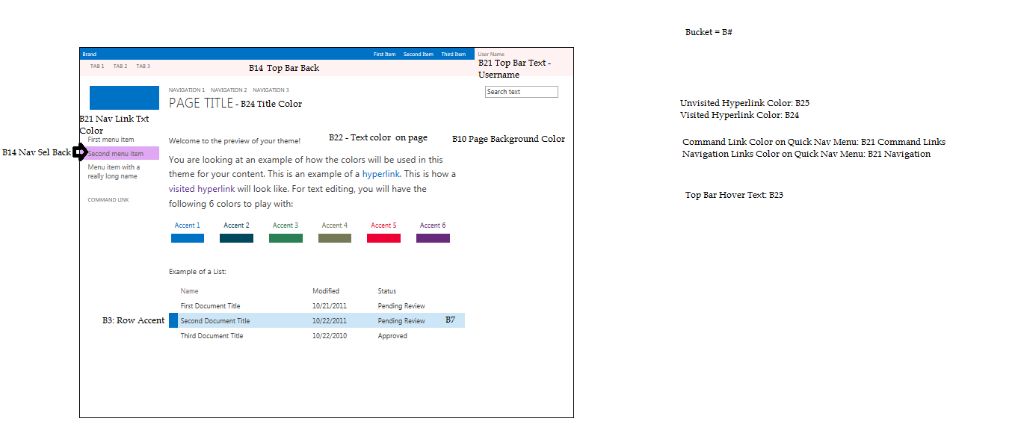

Adding Photos to Contacts Directory
- Add pictures to a UDS Library
- Go to UDS Contact Directory and Click Subsites on Quick Launch
- Click UDS or AI Profiles Library
- Copy JPEG files from UDS Library on Server to UDS Photos Library on Intranet page
- Using Snip-it, take a smaller version of the Photo and Save in UDS Library, Renaming the file and overwriting the current photo. Make sure to save in PNG File Format
- At this point the image size is doubled what is required. View “Large icons” in Library on Server and using Snip-it, frame the picture and save it as the same name. This will reduce the size from 40KB to 20KB.
- Remove the Photos from the UDS Directory Library on the Intranet
- Copy New PNG Files, which are much smaller in size to UDS Directory Library on Intranet

To assign photo to Contact
- Locate person in UDS Directory Library. May require a refresh of the page
- Left-Click the “3 dots” in the lower right-hand corner
- (if doing more than one photo) Copy the link and store it in a word document with the person’s name as a label
- Go to home page of Intranet and open UDS Directory
- Click Edit this list at the top
- Locate the person’s name and select the empty profile pick field
- To the left is a hyperlink icon, click to open
- Copy and Paste the URL of the photo of the person in the word document
- Once Finished, Click Stop editing this list

Uploading Files
- This is typically done through a document or form library
- To do this, access your library through content settings
- Choose a document library
- Click new document at the top of the library
- A new window will appear. If you want to load single documents, you can click Browse. If you wish to load more than one, click “Open with windows Explorer”. This allows you to drag and drop files right into your library.
- When you’re finished. Click ok
- Cancel the Add a document window
- Refresh the intranet page to see your newly added files

Adding Libraries
- Lists, Libraries and other Apps can be used within a subsite and can be helpful with organizing data. To create a list or other type of library, Click Site Contents on the left-hand side of the Intranet window.
- Under Lists, Libraries, and other Apps, click add an app
- Different apps do different things
  - Document Library – allows the storage of files and folders and helps maintain the same folder structure as windows explorer
  - Custom List – allow the creation of custom list with custom column headings where you can define the values you want from a list
  - Form Library – Only allows the inclusion of documents, No Folders
  - Links – used to provide URLs or Network share locations to documents
  - Picture Library – allows the store of photos and will be used in correlation with the adding contact photos
  - Contacts – provides a library to store contact information for individuals
  - Calendar – displays a calendar that can be shared for others to see

Permissions
- Open Internet Explorer
- If you are not at the Intranet home page, navigate to http://intranet/_layouts/15/start.aspx#/SitePages/Home.aspx
- In the upper right corner, click the gear icon and select Site settings
- Under Users and Permission, Click People and Groups
- On the left, under groups, Select the appropriate group based on the users title
- Click New
- Search for the person’s name and wait for it to appear below the search field
- Once the name comes up, click it and click Share
- For guidance on selecting the appropriate permissions, see below
  - Site Administrators: IT Staff or users that need to manipulate pages
  - Site Managers: Staff that need to manipulate sites and subsites, no access to system settings
  - UDS Employees: Standard Read permissions
  - AI Employees: Standard Read permissions

Learning Map
- This is a tool designed specifically for an Introductory Orientation program to working with the various protocols and program interfaces that a Supports Coordinator will deal with on a daily basis. The layout of this tool starts with an informational home page and has various subsites to different data sets such as the SC Tool Kit, Supervisor Tool Kit and an Online version of the SOP. There are also course listings that are setup with easy navigation to get from one course to another. The permissions for this site are setup to fall under the UDS Employees Group, so that no additional access needs to be granted when a new SC starts
- Specific Duties to this site are simply maintenance such as color scheme and making changes to layout and/or adding things.
- Problems: Search Feature is still listed as non-functional which is a desired tool.

Page Permissions
- Content Changes such as adding text, links, folders and files are completed by Jennifer Bond and Sharon Fisher.
- Layout Changes such as library creation, sites and subsites are completed by IT

New Computer and Printer Setup

Software Configurations
UDS HCBS | UDS Administration, HME, Service Dogs, CWS, IT, HR, Facilities | Home Modifications
No Domain | Domain: ucp or corporate.udservices.org | Domain: ucp or corporate.udservices.org
Keynet Automate | Keynet Automate | Keynet Automate
Adobe Reader | Adobe Reader | Adobe Reader
Local Printers – if needed | Local Printers | Local Printers
ESET Antivirus | ESET Antivirus | ESET Antivirus
Google Chrome | Google Chrome | Google Chrome
Cisco AnyConnect | Cisco AnyConnect | Cisco AnyConnect
Remote Desktop Shortcut | Remote Desktop Shortcut | Remote Desktop Shortcut
SAMs Shortcut | Microsoft Office 2016 | Microsoft Office 2016
 |  | Brother iPrint/iScan

Hardware Provided
UDS HCBS | UDS Administration | Home Modifications
Laptop | Laptop | Laptop
Cell Phone | Cell Phone | Cell Phone
Mobile/LaserJet Printer |  | Mobile Printer
Wireless Mouse | Wireless Mouse | Wireless Mouse
Laptop Bag | Laptop Bag | Laptop Bag

New Computer
- Note which company the laptop is going to. This will determine which excel tab you log the system in.
- Open up the UDS Master Inventory_2019.xlsx, found at \\udsfs01\IT Information\Documentation\Hardware Inventory and look for the next available computer name.
- In the IT Inventory spreadsheet, also found at \\udsfs01\IT Information\Documentation\Hardware Inventory, document all information listed
- After documenting the computer system, boot it up and go through the pre-installed setup whether it is windows 10 or windows 7.
- Workstation Setup Process
  - Set the time and date
  - Set the location
  - Allow Cortana
  - US Keyboard only
  - Connect to UDSErinCourt, See UP Spreadsheet, found at \\udsfs01\IT Information, called UP 2-25-19.xlsx for the password
  - Choose Setup for Organization
  - Choose Domain Join
  - Set Username as Admin, no password
  - Choose all default settings until initial setup is complete. Don’t make any changes to the next steps, Choose Yes and/or Next
- After the computer logs in, Type “This PC” in the search bar in the lower left corner
- Choose Computer > System Properties
- Under Device Specification, Click Rename this PC and type in the name. Refer to the UDS Master Inventory_2019.xlsx found at \\udsfs01\IT Information\Documentation\Hardware Inventory for the next available computer name.
  - Use the naming scheme: Desktop###, Laptop###, Tablet###
- Perform a reboot
- After the reboot, navigate to Microsoft Edge and install Google Chrome

Initial Configuration
- Open Control Panel and navigate to Default Programs
- Choose Set your Default Programs
- Navigate to Web Browser and click Microsoft Edge
- Choose Internet Explorer
- When asked to if you really want to switch, choose Switch Anyway

Printing on the SC-Area Copier Only
  - Open a web browser
  - Navigate to 10.0.0.31
  - Login with Username: 7654321, Password: 7654321
  - Click Settings/Registration on the Right
  - Under Management Settings on the left, Click User Management
  - Click Department ID Management
  - Open the following the spreadsheet, EMPLOYEE ID NUMBERS.xlsx found at M:\EMPLOYEE ID NUMBERS
  - Minimize the spreadsheet when it pops up
  - On the web interface of the copier, click Register New Department
  - In the Department ID field, type the Employees ID. Leave the Pin and Confirm Fields Blank
  - Under Page Limit, Place a check mark next to Total Color Prints and Color Copy
  - Click Ok when finished

Finalizing Workstation Setup
Install the following software:

Automate Installation
- Open IT Information Network Share
- Navigate to: Software\KeyNet Technologies\KeyNet Automate
- Run the UDS_Agent_Install.MSI
- Do not modify any of the settings
- Install when Prompted

Automate Name Change
- Open Automate Software
- Right-Click computer and choose Open
- A new window will appear. At the top, right-click the gear icon and choose Extra Data Fields
- In the Friendly Name field, type the employee’s full name
- Click Save when finished

SAMS Shortcut Creation – HCBS ONLY
1. Open Control Panel and view by icons
2. Choose Default Programs
3. Click Set your Default Programs
4. Under Web Browser at the bottom, click Microsoft Edge and choose Internet Explorer
5. Choose the option to Switch Anyway
6. Close the Control Panel
7. Right-click the desktop and choose new > Shortcut

8. Copy and paste the following Link to the location of the shortcut: https://pa.harmonyis.net/sams
9. Set the name of the Shortcut to SAMS
10. Click OK when finished

Adobe Reader
- Navigate to \\udsfs01\IT Information\Software\Adobe\Acrobat Reader\Adobe Reader XI\AdbeRdr11000_mui_Std
- Double-click and run the Setup installer

ESET Antivirus
- Navigate to \\udsfs01\IT Information\Software\ESET
- Run the eea_nt64_enu installer
  - Be sure to set the parameters later
  - Enable detection
- After installer finishes, Open up the application
- Go to Setup
- Choose Enter advanced Setup
- Expand Tools and highlight Remote administration
- Check the box next to Connect to Remote Administrator server
- Under the primary server tab, Type: eset.keynettech.com, port should be 2222
- Click Ok and then exit the application

Cisco AnyConnect
- Navigate to \\udsfs01\IT Information\Software\Cisco AnyConnect
- Extract the zip file to C:\Program Files(x86)\Cisco AnyConnect (Note: Cisco AnyConnect folder will need to be created)
- Run the Setup Application
- Once the application opens, Select the following options only:
  - Core & VPN
  - Start Before Login
  - Diagnostic And Reporting Tool
- Click Install Selected
- Upon completion, navigate to the installed file on the computer, right-click and choose open file location
- Once the location opens up, right-click the application and choose send to > Desktop
- Open Cisco AnyConnect
- In the address field, type vpn.udservices.org and Click connect.
- Enter your username and password to save the address
- Once connected, open the application and disconnect

Remote Desktop Connection
- Navigate to the location this application installed on the computer
- Right-Click and choose Open File Location
- Once the location opens up, right-click the application and choose send to > Desktop
- Open the application and add the appropriate IP or Host name and Click Save Connection
- Open Remote Desktop Connection
- Check Users 04 and 05 Spreadsheet found in: K:\IT\Server Documentation to see what server the user should be on.
- Type the hostname in the address field and click connect
- Login as the user. <Firstnamelastinitial>, password is UDS<season><current year as YYYY>

Updates
- In the bottom left-corner on your screen, click the search field and type check for updates if a windows 10 machine or Windows updates for Windows 7
- Choose check for updates and be sure to install as many as possible

Printers – HCBS and Home Mods Only
1. SCS will either receive a mobile printer or brother LaserJet. If plug and play doesn’t work, download the driver for the particular model(i.e. MFC-2750DW) on the manufacturer’s website.

SCANS Folder Creation
- Login to the server as the user
- In their L:\ Drive, Create a folder called “SCANS”
- Right-click that folder and send to desktop
- Minimize the server
- Right-click the local desktop
- Create new shortcut
- In the location, type: \\192.168.10.10\Users\<username>\SCANS\
- Call the folder SCANS

Brother MFC-2750DW Print/Scan Software
NOTE: Make sure you have a brother printer available to connect to during the installation.
- On the local side of the computer, Navigate to the following link: https://support.brother.com/g/b/downloadlist.aspx?c=us&lang=en&prod=mfcl2750dw_us_eu_as&os=10013
- Under Utilities, Click Brother iPrint&Scan
- Agree to the terms and the download will occur automatically
- Open the software after it has finished downloading and complete the installation process
- After the installation, launch the application
- Once you have connected the printer, Click “Select your Machine” in the lower right-hand corner
- Select the machine that is connected
- Near the top, click “Create Workflow”. You need to create (1) for single sided and (1) for double-sided. Be sure to make them a one click option but checking the box at the end up the setup.
- Make the save location the SCANS folder on the person’s desktop
- If you make a mistake in the workflow, click the gear in the upper left corner and choose workflow management

For Domain Workstation Setups ONLY
- Open Registry
- Go to HKEY_LOCAL_MACHINE\SOFTWARE\Microsoft\Windows\CurrentVersion\Policies\System
- Right-Click HideFastUserSwitching and choose Modify
- Set the data value to 0 to enable the feature.
- Close the Registry

Account Setup

- The user account can be created in Active Directory, located on the server: 192.168.10.29
  - Copy an existing employee from the same department that has the same title
  - Set Alias as <firstname><lastinitial>
  - Set Password as “UDS<season><currentyear AS YYYY>”
  - Leave all password radio buttons blank
  - Click Ok
- The user email account can be created in Exchange, located on the server: 192.168.10.9
  - Click the plus sign at the top and search for the newly created profile
  - Create an Alias. Naming scheme: <firstname><lastinitial>
  - Verify everything is correct and click Ok
- Once both of these accounts have been created, the workstation can be configured for the user

Form Tracker Account
- Navigate to https://formtracker.udservices.org/users/login
- If you are creating a new HCBS staff member, proceed to step 3. If you are creating a new Admin, proceed to Step 7.
- Click the Staff Tab
- Choose “Create New Staff” on the left
- Fill in all information, username is the same as network account. If you do not know their supervisor or manager, you may leave it blank.
- Click Save when finished.
- Click the Admin Tab
- Choose “Create New User” on the left
- Replicate information from network and email account.
  - Set Password to their current network Password. Usually “UDS<season><currentyear AS YYYY>”
  - Choose Active Checkbox and Click Create.
- Choose new role and assign the correct value.
  - SC = Staff
  - SC II = Supervisor
  - Program Specialist = Manager
  - IT Staff or Admin rights = Admin

Configuration of User Account
- Assign user to a server. (Be sure to balance out all servers)
- Go to M:\EMPLOYEE ID NUMBERS
  - Look for the 4-digit id for the person you are setting up
  - Take note of that number
- Login to the server as the new employee
- Open Outlook
  - Create their signature by copying another person’s email signature
    - Take note of the department they are in.
    - Different departments have different signature layouts. (see pages 43-45)
- Open K:\Apps
  - Select the correct Databases needed based on their department. (see Table Databases on page 36)
  - Double-Click the specified icons per the department they belong to
  - Verify access to Databases
    - Caseloads
      - login with employee id # obtained in step 2
      - Click DAR Menu
      - Daily Activity Entry
      - Verify that the persons name shows up in the field next to Supports Coordinator
      - If everything is correct, Click the x in the upper right to close the database
      - If not, contact a Database Specialist in the department
    - Halo
      - Make sure home screen opens
      - Close the database
    - Expense Reports
      - Make sure you can select the persons name in the drop-down
      - If so, close the database
      - If not, contact a Database Specialist in the department
    - Scorecards
      - Click Reviews
      - Search for the person from the Drop-Down next to Staff Person
      - You may get prompts stating that a review has not been created. Just click Ok
      - Verify that a 90 day has been created for these parameters:
        - 2018-2019 Fiscal Year and 90-day Review Type
        - 2019-2020 Fiscal Year and Annual Review Type
        - If there are reviews setup for both of those, close the database.
        - If you receive a prompt that a review has not be created for either one or both, contact a Database Specialist in the department
- After everything has been verified, Sign out of the user account and send an email with the following content:
  - To: New Hire, Their Supervisor
  - CC: Erik Lofgren
  - Subject: ”<New Hire’s Name><Credentials>
Body:
Network login:
Server: Please have <new hire firstname> login to server <specified server>
Username: <firstname><lastinitial>
Password: UDS<currentseason><current year AS YYYY>

Halo and Caseload Databases:
Username: <firstname><lastinitial>
Password: 4-digit id found in M:\EMPLOYEE ID NUMBERS spreadsheet

Form Tracker:
Username: <firstname><lastinitial>
Password: UDS<currentseason><current year AS YYYY>

SC AREA Copier Department ID: 4-digit id found in M:\EMPLOYEE ID NUMBERS spreadsheet

Department Signature Templates

HCBS
<Firstname Lastname>
<Job Title>
United Disabilities Services
Work 717-397-1841
Toll Free 800-995-9581
Fax 717-947-7446
<email>



- Save Signature and close outlook
- Log out user
- Install printer (if needed)
- Configure Cell Phone. Call Verizon Technical Support if needed: 1-800-922-0204
- Print label of cell phone number and place on back of cell phone
- Review Equipment with user

IT, HR, Administration, Facilities
<Firstname Lastname>
<Job Title>
Office <Phone Number>
<email>



- Save Signature and close outlook
- Log out user
- Install printer (if needed)
- Review new equipment with User

Service Dogs
<Firstname Lastname>
<Job Title>
UDS Service Dogs
Office 717-397-1841
<Cell Number>
<email>




CWS, HME
<Firstname Lastname>
<Job Title>
United Disabilities Services
Work 717-397-1841
Toll Free 800-995-9581
Fax 717-947-7446
<email>



Home Modifications
<Firstname Lastname>
<Job Title>
Accessible Home Modifications
Work 717-397-1841
<email>



Key Fobs
Upon hiring a new employee, a key fob will be issued to gain access to the building. This fob will be issued by IT and need to be logged both on Yarnell’s Web interface as well as the IT Inventory Spreadsheet
  - Choose a key fob
  - Located the left-most number on the sheet of paper that comes with it. (usually in the bag that the fob is in)
  - Navigate to: https://www.virtualkeypad.com/systems/153621/doors

New Hire Check List
- Have user open laptop, check charger and mouse
- Double click Cisco AnyConnect icon on desktop and check VPN server says “vpn.udservices.net”
- Login onto VPN using username: “FirstL” and password: “UDS<currentseason><currentyear>”
- Double click Remote Desktop icon on desktop and enter server name “UDSTS0X” given to you
- Login again using same credentials as step 3
- If it gives an error, make sure the domain is set to UCP
- Show user Outlook and Jabber and make sure they can be opened and logged in to
- Make sure a signature is set for the user in Outlook
- Makes sure Reviewer permissions have been added to the following individuals in the Calendar, Karen Slick and Receptionist
- Double click Internet Explorer and make sure the user can get into the Intranet
- Show user how to manage between the server and local desktop windows
- Show user how to log out of the server when they are done

New Printer
- When a new printer arrives, document the make model and serial under the appropriate company in the IT Inventory Spreadsheet, found at \\udsfs01\IT Information\Documentation\Hardware Inventory
- If the printer is to be networked, please make note of the IP in the spreadsheet as well. Identify an IP that is not in use and assign it to the printer.
- Setup the printer in the pre-determined location and perform a test print.

Domain Printer Configuration
- Obtain the Driver for the printer and install all company servers. Take note of the printer name chosen and copy the text and store for later
- Open up Active Directory, 192.168.10.29
- Create a Printer Group for the new printer in active directory (UDS Security Groups | Terminal Server Groups). Name the new group the same as the printer you created in step 1.
- Access \\UDSDC01\netlogon\TSPrinters. Copy and paste a .vbs file, rename it to match the name of the printer that you created in step 1. (Be sure to make the name exact or things will not work)
- Right click and select edit on the new file, change the name of the Printer in the “PrinterPath” section. Save and exit the file (Be careful to make the name exact or things will not work)
- Access \\UDSDC01\netlogon\.
- Right click on TerminalServerLogon.kix, choose edit. Copy an existing section that defines a printer script. You will copy from “If InGroup” to “EndIf”. Paste and modify the InGroup Name to be the same as the AD group you created in step 2. Modify the Name of the .vbs script to be the same as the new script you created in step 3. Save and exit the file

Meter Readings
- Emails are received from colony to provide specific copier counter details. To get this information, log on to a UDS Server
- Open Internet Explorer
- Enter the IP Address in the Address Field
- Login to the Printer
  - 192.168.0.7 – Williamsport, Username: Administrator, PW: 123456
  - 10.0.0.27 – 2nd FL Administration, PW: 17605
  - 10.0.0.30 – 1st FL Copy Room, PW: 17605
  - 10.0.0.31 – SC Area, Username: 7654321, PW: 7654321
  - 10.0.0.12 – Garden Level, PW: 17605
- Extract the information needed in the meter readings request emails

Inventory Tracking
- All hardware products that are in possession of employees such as laptops, desktops, tablets, printers, cell phones, monitors and docks are stored in IT Master Inventory_Qtr_4 spreadsheet.
- Personnel who are assigned to each of these devices are also listed along with active or terminated, start date, cell phone and/or desk phone, department and location
- Updated on a quarterly basis or when there are new hires/terminations
- Domain printers are also stored with serial number info and IP assigned
- A quick way to obtain a computer name and serial # if missing is through the command prompt
  - Command: wmic bios get serialnumber and wmic bios get computername
- Action to do this is done manually at this time.

UDS Inventory Audits
- Audits are performed at the end of every quarter
- Quarterly End Months are: March, July, October and December
- Look for missing equipment, serial numbers, etc.
- Updates on new hires or terminations
- Inventory is modified in the IT Master Inventory_2019.xlsx
- Upon the completion of an audit, rename the spreadsheet to reflect the year and the quarter the audit is performed.

Software Tracking
- All software is saved in the \\udsfs01\IT Information\ network share under the software folder
- Licensing information for those products that have it are stored with the software itself or the licensing folder
- If a product is licensed, the documentation of that license is kept in an excel spreadsheet found in \\udsfs01\IT Information\Documentation\Licensing
- A list of products is found in the following spreadsheet:
\\udsfs01\IT Information\Documentation\Software Inventory

Verizon
- To access our Verizon account and view wireless and MiFi numbers, navigate to the following site: https://sso.verizonenterprise.com/amserver/sso/login.go?appGroup=VZW&goto=https%3A%2F%2Fb2b.verizonwireless.com%3A443%2Fsms%2Famsecure%2Flanding%2Foverview.go
- The username and password are found in the UP Spreadsheet, found at \\udsfs01\IT Information, called UP 2-25-19.xlsx
- Click Manage Account, then Manage Wireless Numbers
- This will list all the phone numbers we have associated with all our Verizon accounts for employees. To modify data for a number, simply click the (+) next the phone number to view information. This will also allow you to change the name on an account as well as reset their voicemail pin.

How to Forward a Phone to an Extension & Setup Jabber
- Go to: https://10.1.0.250
- Enter username and password from UP 8-19-19
- Click the “Device” tab at the top
- Click “CTI Route Point”
- Click “Find” without any search credentials to find an unused extension or find the last used extension and add one (keep this number for later)
- Click “Add New”
- Under “Device Name” enter “SD_FirstLastInitial”
- Under “Description enter “First Last – XXX-XXX-XXXX”
- Under “Device Pool” select “Lancaster” or what ever applies
- Under “Calling Search Space” select “LancasterLD”’
- Click the save button (see below for an example)

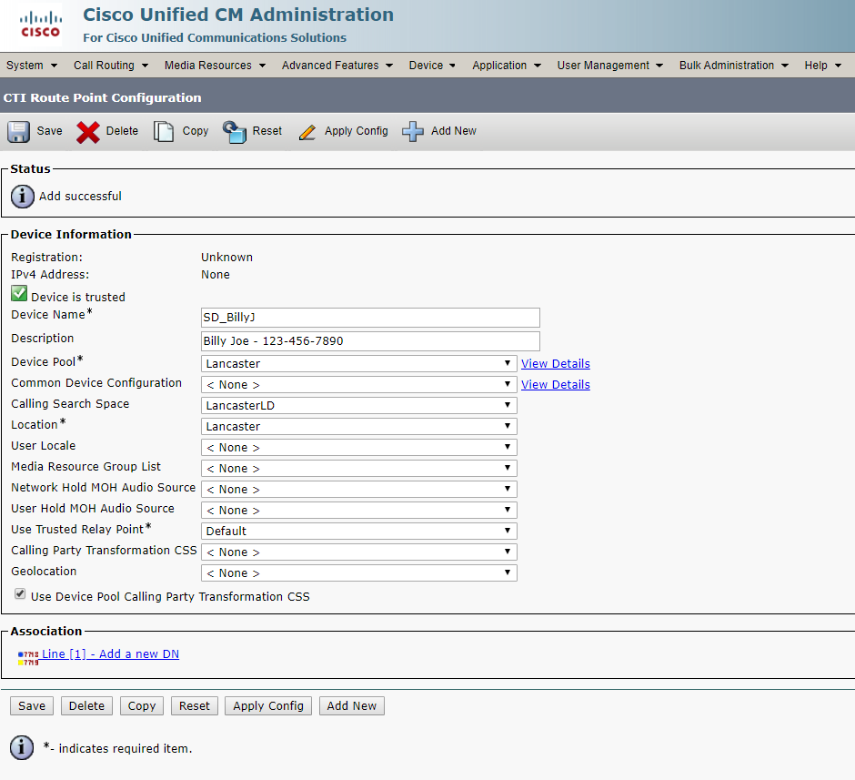
- Click “Line [1] – Add a new DN” under “Association”
- Under “Directory Number” add the extension you found earlier in step 5
- Under “Description” enter the same as the last step: “First Last – XXX-XXX-XXXX”
- Under “Alerting Name” enter “First Last”
- Under “ASCII Alerting Name” enter “First Last”
- Under the heading “Call Forward and Call Pickup Settings” find “Forward All”
- Under “Destination” enter the phone number plus 9 in the beginning with no spaces: “9XXXXXXXXXX“
- Under “Calling Search Space choose “LancasterLD”
- Click save in the upper left hand corner (see below for example)
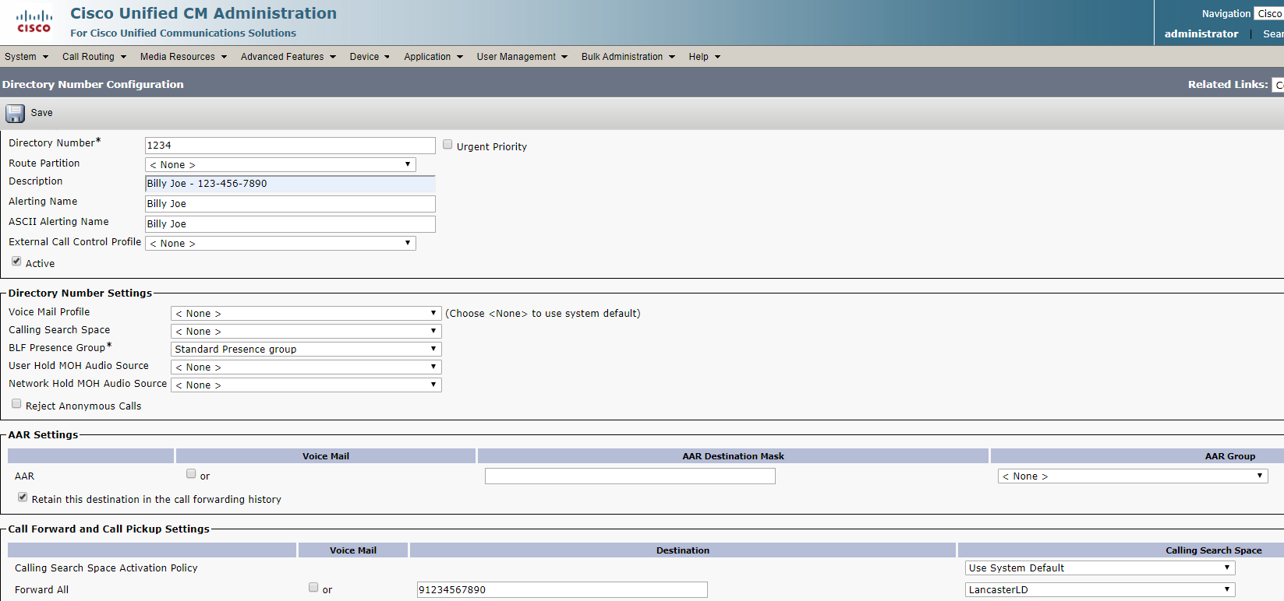

- Click “User Management” tab at the top
- Enter user’s first name and click find
- Click the user ID below
- Scroll down until you see “Service Settings”
- Make sure “Home Cluster” & “Enable User for Unified…” are checked (see below).
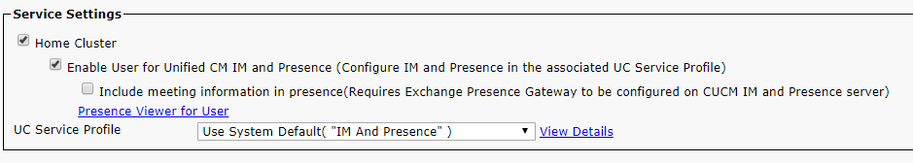

Barracuda

Recovering a file using Barracuda Backup
- Backups are kept via a cloud service found on the file server. To access the Barracuda Backups, Open the Remote Desktop Connection Application and navigate to UDSFS01.
- Login to the server is the Administrator Login with credentials found in the UP Spreadsheet, found at \\udsfs01\IT Information, called UP 2-25-19.xlsx
- Once logged in, go to Internet Explorer
- In the address field, type 192.168.10.36
- Login using credentials from the UP Spreadsheet, found at \\udsfs01\IT Information under Barracuda 790, called UP 2-25-19.xlsx
- Once logged in, Click the Restore Tab and choose Restore Browser
- The contents of the backup will appear. Click UDSFS01
- Choose Backup Agent
- Choose File Systems
- Select D:
- Select Company Data
- This will show all the Network Shares on the File Server. Depending on the file or folder you need to recover will depend on its location. Obtain the path before you do the recover as it will be easier to complete the backup
- Click a network share
- Trace the path
- If the file does not appear, on the left, under RESTORE BROWSER, you will see grey text that says, “Showing backups from” and then a calendar date. Change the date until you see the file or folder you are looking for.
- Once you find the file or folder, click the checkbox next to it and click Restore to the right
- You can choose to either restore the file or folder to the original location or the C:\ Drive of the file server. This is a personal choice. If the file is missing, restoring it to the original location is your best option.

Email Filter
- When it comes to monitoring emails with the UDS network, the spam filter is used. To access the email filter, open a web browser and navigate to: https://email.knthosting.com/cgi-mod/index.cgi
- If you do not have an account that utilizes your email with this application, you can login with the Administrator Account.
- Once you are logged in, a list of current domains will be shown. Click Manage Domain, next to udservices.org
- After you click the domain,
  - You can view all emails, incoming and outgoing in the message center
  - Whitelist and Blacklist Items in the Block/Accept Tab
  - Check user accounts with the Application in the Users Tab.
- Those are the 3 primary feature that will be utilized, however the most important is the Block/Accept tab
- Click the Block/Accept Tab and Choose Sender Filters
- If a domain needs to be whitelisted, it is added under the Allowed Email Addresses and Domains and if the domain needs to be blacklisted, it is added to the Blocked Email Addresses and Domains.
- The same is for Recipient Filters.

Open DNS
- Open DNS is the Web filter and can be accessed by opening up a web browser and navigating to: https://www.opendns.com/
- Click Login in the upper right corner of the window
- The Login Credentials are found in the UP Spreadsheet
- To whitelist or blacklist a website, on the left, click Policies
- Choose Destination Lists under Policy Components
- To Allow websites, Click UDS Allow List
- Type the Domain in the field below Destinations on this list will be ALLOWED and Click Add
- To Block websites, Click UDS Black List
- Type the Domain in the field below Destination on this list will be BLOCKED and Click Add

Cell Phone Configuration
- Verizon Cell phones are used, and the typical models include Kyocera Flip phones, Droids and Samsung Galaxy phones
- For the flip phones, you will typically need to contact Verizon support at: 1-800-922-0204
- For the 4G phones, if you are swapping, just swap the sim card. If you are setting up a new phone, you will need to call Verizon Support.
- Be sure to configure corporate email on the phone.
- Verify that emails are downloading and that the calendar is syncing as well
- Change the name in the Verizon account and provide to the employee
- Setup a Gmail account
  - Create a new account under these parameters:
    - Email: <uds><firstname><last initial>
    - Password: UDS@2270!

On-Call Setup for SCs
- Navigate to: K:\HCBS Documents\OCschedule_2018 – original and open the Excel Spreadsheet.
- Look for today’s date and take note of who will be on call and how long.
- Open up a web browser and navigate to: https://sso.verizonenterprise.com/amserver/sso/login.go?appGroup=VZW&goto=https%3A%2F%2Fb2b.verizonwireless.com%3A443%2Fsms%2Famsecure%2Flanding%2Foverview.go
- Login into the UDS Business Account using the Username and Password from the following location: (Click here) UP Spreadsheet, found at \\udsfs01\IT Information, called UP 2-25-19.xlsx.
- After logging into the UDS Verizon Account, Click Manage Account. Under Service, click Manage Wireless Numbers.
- Scroll until you see the person that will be on call. COPY their cell phone number.
- Look for Bollow, Susan or Phone # 717-947-0146. Expand this user. (You can find this person by filtering <wireless number> highest to lowest.)
- Their account is associated to the line that receives calls outside of normal business hours or to the on-call SC. Under this users account, Select Manage Call Forwarding
- Under Forwarding Options, Click Setup call forwarding to a new number. Then select Forward all calls.
- Under Enter number to receive calls, PASTE the SC’s number as you did in Step 5 into the field below.
- Click Submit to confirm changes.
- Call the on-call number, 717-947-0146 to verify that forwarding works. If the SC picks up the phone, let them know that they are on call. If you receive a voicemail, please leave one and then email the SC to provide another means of contacting them.

Faxing

From Computer
See in-depth documentation found on the IT Network Share: Click Here

From Copier
- Standing in front of the copier, click Facsimile
- Enter the fax number but include a “9” in front of it, if you are faxing out of the 717 area code
- Place the document on the document feeder, words placed down
- Click Send

Domain Error Troubleshooting
- If a domain trust relationship issue is found, remove the person from the domain, and re-add them. Remember to take note of the Local Admin password before you remove them from the domain.
- If the computer cannot see the domain, or there are issues connecting to the domain, check the computer name. Perform a release/renew of the IP in command prompt, and/or search for a solution on Google. Re-imaging a PC will solve this issue, but should be avoided if possible

Copier Color Issues
- From a Canon copier, login using 7654321 as the Username and 7654321 as the Password
- Click the Settings/Registration button on the copier
- Choose Adjustment/Maintenance
- Click Adjust image quality
- Select Auto Adjust gradation
- Proceed through the steps on the copier touch screen
- When finished, Choose Auto Color Mismatch. This is an automated process
- When finished, tap the main screen button to return to the main menu

Database Troubleshooting

UDS Caseloads
- Use the following instructions in the event an employee cannot open their DAR or another feature in the SC Caseloads database.

- Navigate to K:\HCBS Documents\Caseloads\Production\Users
- Open the user’s folder
- Check to make sure the access database does not have a locked file. “.laccdb”
- Delete the SC_Caseloads_FrontEnd.accdb file
- Ask the employee to re-open the database

UDS HALO
- Use the following instructions in the event an employee cannot open their DAR or another feature in the SC Caseloads database.
- Navigate to T:\Production\Users
- Open the user’s folder
- Check to make sure the access database does not have a locked file. “.laccdb”
- Delete the Halo4United.mdb file
- Ask the employee to re-open the database

Yarnell Door Access

Accessing the Web Portal
- Open a web browser
- Navigate to https://www.virtualkeypad.com/systems/162773
- Login with username and password found in UP Spreadsheet under Yarnell, found at \\udsfs01\IT Information\
- Depending on the system you access, Erin Court or Corporate Blvd, will depend on which code to use, also found in the UP spreadsheet

Adding Users

Erin Court
- Login to Erin Court, use code found on UP Spreadsheet
- Click Users on left
- Click Users + at the top to add a user
- In the First Name field, use the following schema: Fob# - Firstname
- In the Last Name field, Type the Last Name
- Under Profiles, select STAFF
- Type should be set to Code
- Input the 5-digit code found on the slip of paper with all the key fob numbers
- Click Save

Corporate Blvd
- After logging in, click Switch System
- Use code found in up spreadsheet to access system
- Click Users on left
- Click Users + at the top to add a user
- In the First Name field, Type the users full name, <Lastname>, <Firstname>
- In the Last Name field, Type the 7-digit code found on the back of the key fob
- Under Name, Put the persons name
- Type should be set to Code
- Uncheck the box next to “Use first available number
- Input the 5-digit code found on the slip of paper with all the key fob numbers
- Click Save

Documenting Users

Common Issues

Problem: Copier can't communicate to SMTP Server

Resolution
      - Go to the Exchange Server
      - Open Mail Flow
      - Click Receive Connectors
      - Choose SMTP Relay
      - Select Scoping
- Click “+” to Add IP to Remote Network Settings

Contact Information
Company | Contact Info | Notes
Colony | 717-569-5900
Weaver | 717-394-5009 | Contact: Danielle Maze
Verizon | 1-800-922-0204
Davis | 610-264-1600

UDS Copiers
Company | Name | Location | ID
Colony | Canon ImageRunner C5255A | 2nd FL Administration | 14454
Colony | Canon ImageRunner C5535 | 1st Floor Copy Room | 14851
Colony | Canon ImageRunner 5550 | SC Area | 14800
Colony | Canon ImageRunner 3525i | ASB – 2260 Erin Court 2nd FL
Colony | Canon ImageRunner 3525i | Garden Level | 14824
Davis | Canon ImageRunner 3525 | Tamaqua UDS Office | XTK02577
Davis | Canon ImageRunner 3525 | Tamaqua ILS Office

Server Information
192.168.10.9 – UDS Exchange | 192.168.10.29 – UDS Active Directory
192.168.10.100 – SQL Server | Udsts03/udsts09/192.168.10.12 – UDS User Servers
192.168.10.10 – UDSFS01 | Udsts04/udsts05/udsts07/udsts08 – UDS SC Servers

Software Web URLs
Name (Click Name to access site)
Barracuda Spam Filter
Annkissam Help Desk – Form Tracker
Cisco Phone Admin
Cisco Phone VM Admin
EMAG
Cisco Phone Portal
Verizon Business Account
Verizon Network Fleet
Connected Sign

